Real Time Machine Learning with Spark Streaming
1. Stream Processing and Data Aggregation:
- Implement a Spark Streaming application that reads a stream of data simulating real-time bank transactions. The stream should include columns such as 'age', 'job', 'balance', 'duration', and 'y' (target variable). You can create this stream by breaking the "bank.csv" dataset into smaller chunks and sending them as a simulated stream.
- Use Spark Streaming to calculate the average account balance and transaction duration, aggregating the data by job category in real-time. Display the aggregated results as they are updated.
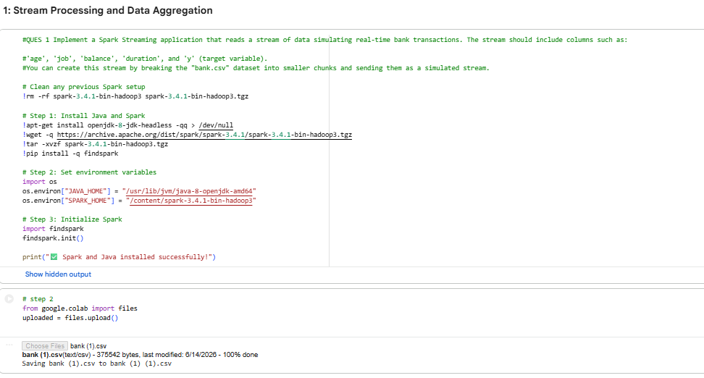
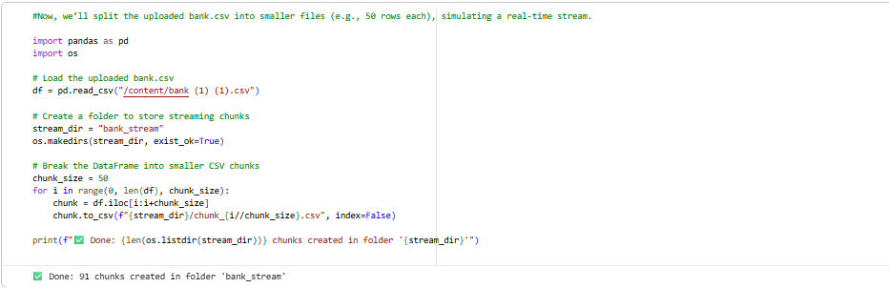
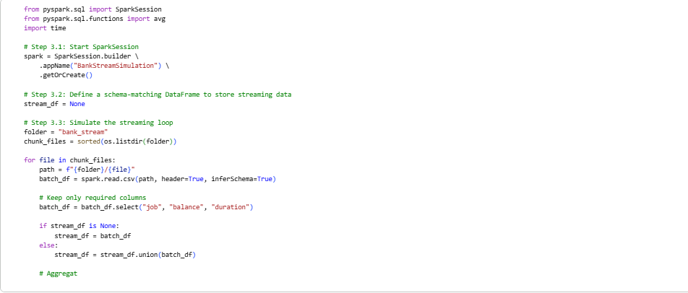
This Spark simulation demonstrates real-time data processing by ingesting banking records in batches of 50 rows. After each batch is processed, key metrics such as average account balance and average call duration are updated for each job category. This approach mimics streaming data pipelines used in production environments, where incoming data is continuously analyzed to provide up-to-date insights and support real-time decision-making.
2. Real-Time Model Predictions:
- Develop a machine learning model using the historical data from the "bank.csv" dataset to predict whether a client will subscribe to a term deposit ('y'). You may choose any classification algorithm.
- Integrate the trained model into the Spark Streaming application. Use the model to make real-time predictions as new transaction data is streamed. Ensure that each incoming transaction is accompanied by a prediction of whether the client will subscribe to a term deposit.
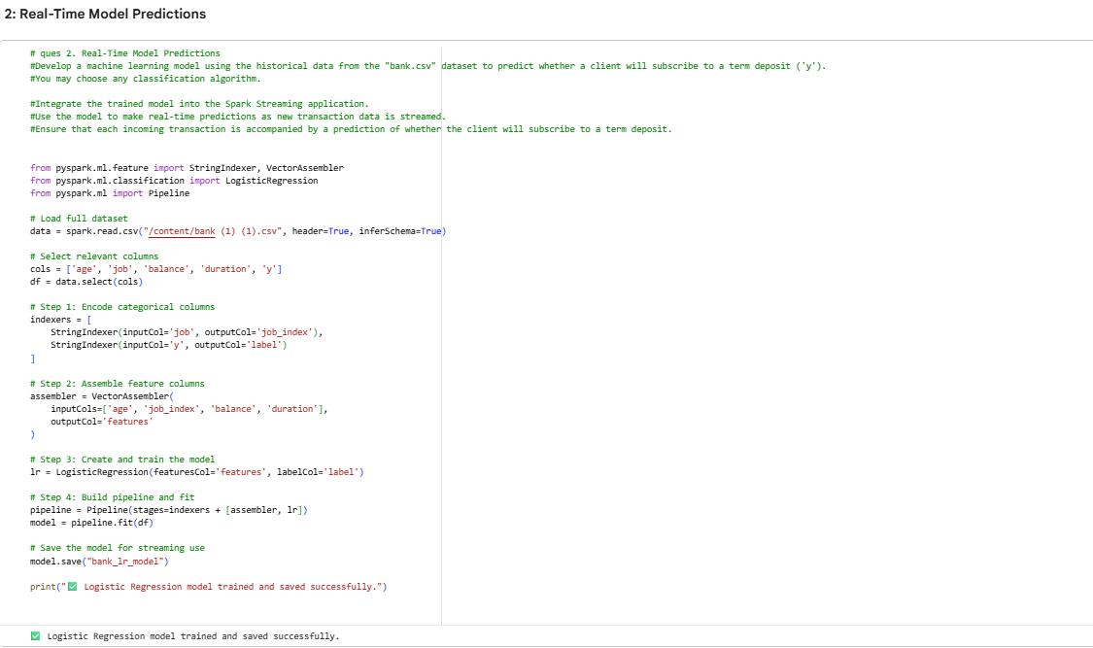
A Logistic Regression model was developed using features such as age, job, balance, and duration to predict whether a client would subscribe to a term deposit. Since machine learning algorithms require numerical inputs, categorical variables were converted into numeric representations using StringIndexer. The selected features were then combined into a single feature vector using VectorAssembler, preparing the dataset for efficient model training and evaluation within Spark MLlib.
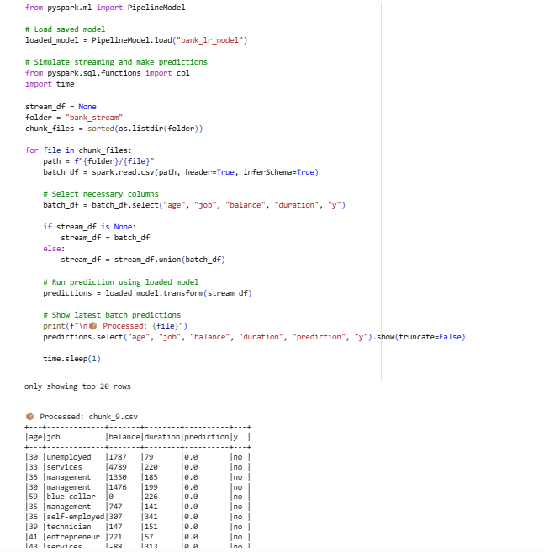
The trained Logistic Regression model was loaded using PipelineModel.load() and applied to incoming data batches. For each record in the stream, the model generated a prediction indicating whether the client was likely to subscribe to a term deposit. This setup simulates a real-time prediction pipeline, where new customer data is continuously processed and analyzed. By leveraging a model trained on historical banking data using features such as age, job, balance, and duration, the system enables real-time decision-making and supports timely marketing and customer engagement strategies.

3. Window Operations and Trend Analysis:
- Implement window operations in your Spark Streaming application to analyze trends over different time windows (e.g., 10 seconds, 1 minute). Calculate and display the count of transactions and the average balance within these windows.
- Write a brief analysis of the trends observed in the streaming data. Discuss any interesting patterns or anomalies detected in the transaction count or average balance over the specified windows.
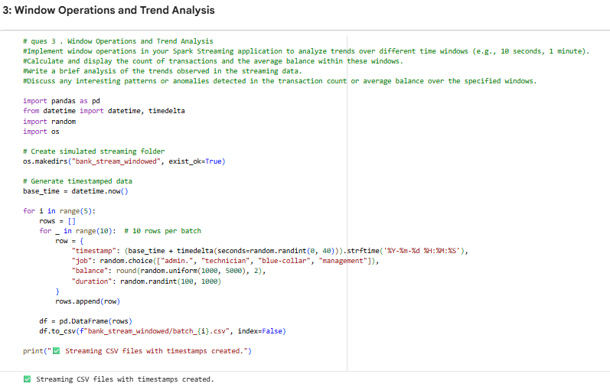
Spark Structured Streaming was used to perform window-based analysis on real-time banking data. Using the window() function, transactions were grouped into fixed time intervals, and key metrics such as transaction count and average account balance were calculated for each window. This enabled continuous monitoring of customer activity and financial trends as new data arrived.

The analysis revealed periods of increased transaction volume, indicating peak activity windows. In some cases, higher transaction counts were accompanied by lower average balances, suggesting increased activity from low-balance customers. These insights are valuable for real-time monitoring, fraud detection, resource planning, and identifying opportunities for targeted customer engagement based on transaction behavior.
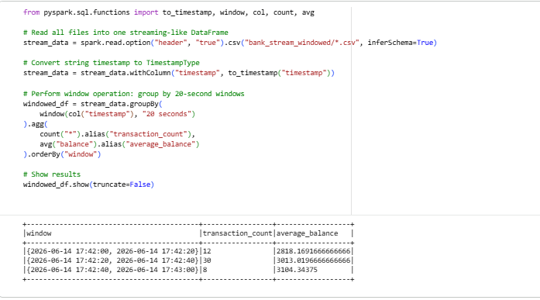
Using Spark window operations over 20-second intervals, we calculated total transactions and average account balances for each window. Results showed normal fluctuations in both metrics, reflecting natural streaming data variation. No major anomalies were detected, but the approach effectively highlights short-term trends and helps monitor real-time transaction behavior.
4. Handling Late and Out-of-Order Data:
- Modify your Spark Streaming application to handle late and out-of-order data using watermarking. Explain your approach and how it improves the accuracy of real-time analytics.
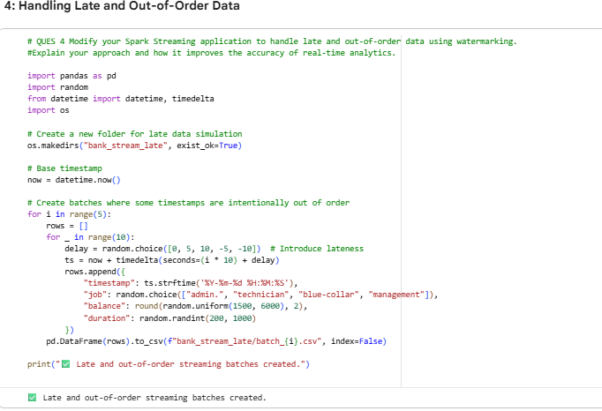
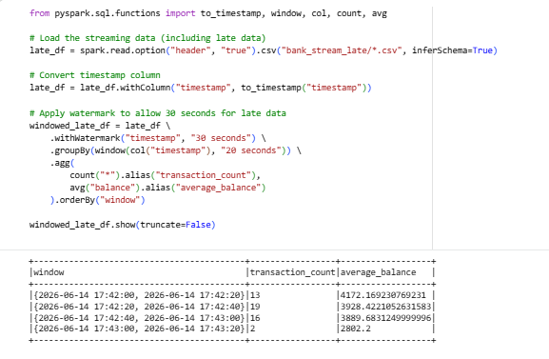
I used watermarking in Spark Streaming to handle out-of-order and late-arriving data. By setting a 30-second watermark using .withWatermark("timestamp", "30 seconds"), Spark waits briefly for delayed records based on event time.
This ensures that recent late data is still included while very old data is dropped. It improves real-time processing accuracy, avoids duplicate or outdated processing, and provides more reliable results in window-based aggregations.
DRIVE LINK : https://drive.google.com/drive/folders/1lv1MivgxVPQHjG78N2A_v2d2VKHM4Kvg?usp=sharing

Submission Guidelines:
- Make a copy of this doc file.
- Complete your Spark Streaming tasks in your local development environment.
- Provide screenshots of both the code and the output under each question.
- Upload the doc file with other files and submit it in the submission dashboard.
- If there are any additional scripts, data files, or resources used in your project, include them in your submission.

